27th June 2016

FIA WTCC Race of Portugal boosts Championship Battle

The FIA World Touring Car Championship interest was raised at the weekend’s Race of Portugal following two spectacular and interesting results.

Veteran Dutch driver Tom Coronel added a second victory to his tally this season, thanks to his experience and being able to keep former team mate, Tom Chilton at bay on the streets of Vila Real. Coronel managed his pole position at the starting grid very well and had to contend with Chilton for the duration of the opening race. It was a two-Tom race with Nicky Catsburg keeping close by in third position. Two privateers in the podium was exciting for the large crowds who had gathered to see the thrills and spills of the street race, and especially to support their “Home” hero, Tiago Monteiro, who ended on P10 on the first race. In fifth place, last season’s Champion Jose Maria “Pechito” Lopez, added some points to maintain a healthy Championship lead.

For the crowds, the best was yet to come. Tiago Monteiro fulfilled a perfect main race, and gave the many hardcore fans, a fantastic Sunday. The Honda driver led from lights to flag after making a great start, but was pushed very hard, all along to the chequered flag by Citroen’s Yvan Muller. Tiago Monteiro, was at home, and having nursed his bruises well, following his crash during the Race at the ”Green Hell” a couple of weeks ago, was hoping for this kind of performance and result. Norbert Michelisz completed the podium after being able to keep in front of team-mate Rob Huff towards the latter part of the race and Honda securing valuable manufacturer points with a 1-3-4 finish.

Once again, Jose María Lopez kept within the top group and his second fifth place of the weekend, provided some more points to maintain a healthy lead in the overall standings, although with a very motivated Tiago Monteiro looking forward to the next race.

The Race of Portugal concludes the European races of the Championship which will now cross the Atlantic to resume in Argentina, on the 6th & 7th August.

Current Driver Championship standings:

Jose Maria Lopez 244 pts
Tiago Monteiro 143 pts
Nicky Catsburg 139 pts

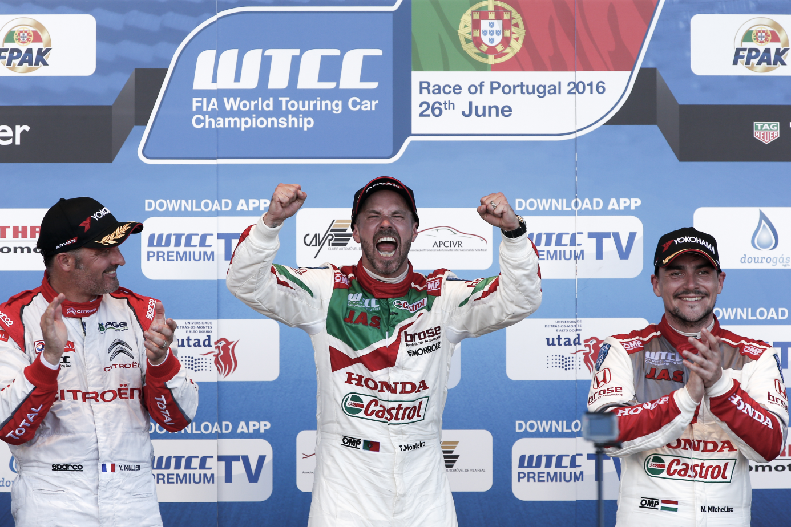
Monteiro celebrates victory at home race

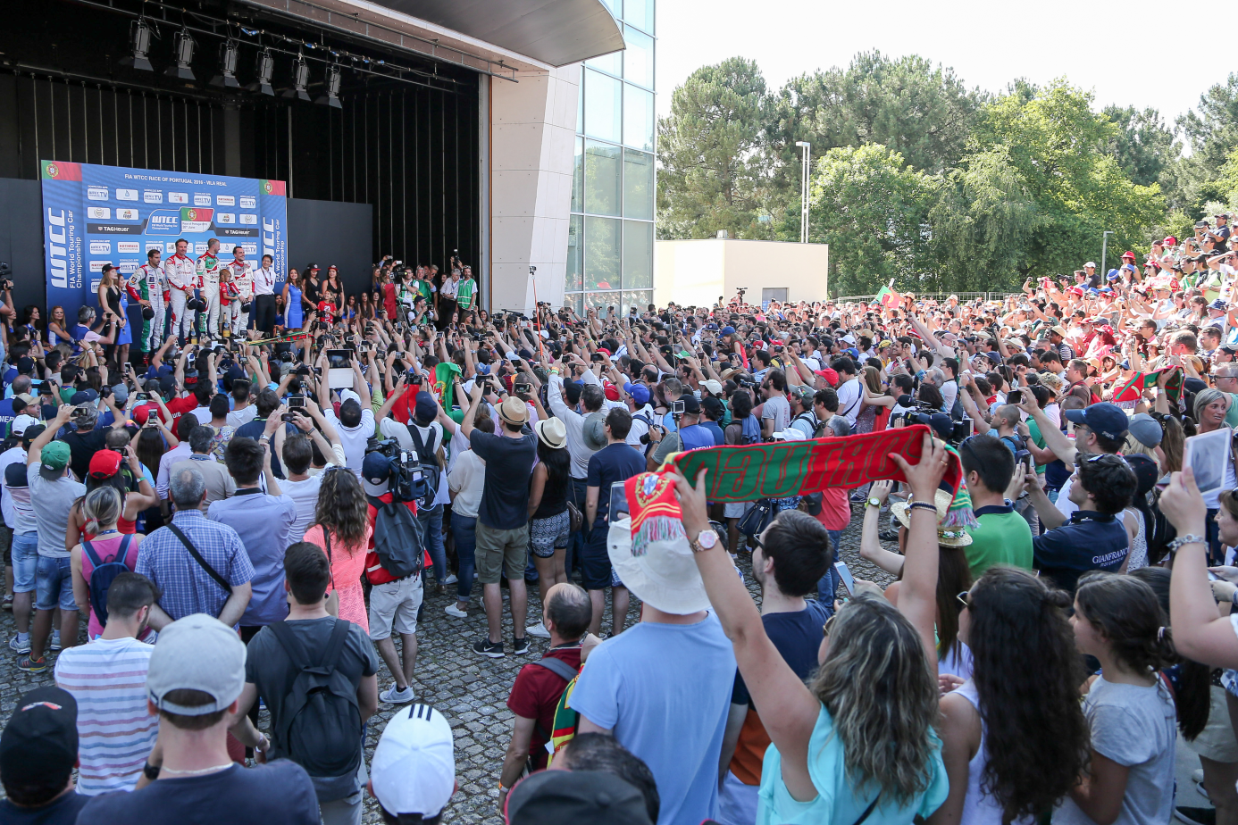
Crowd support for home favourite Monteiro

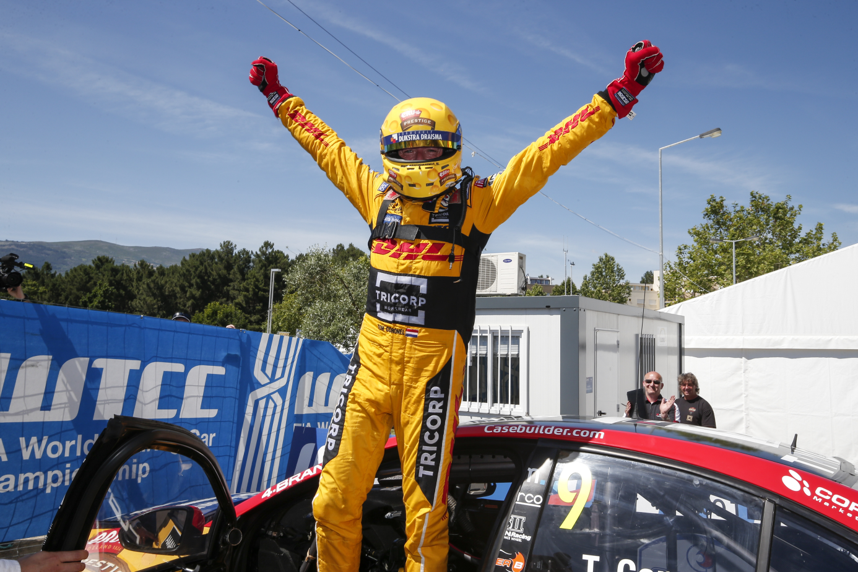
Tom Coronel ecstatic after win in Portugal

